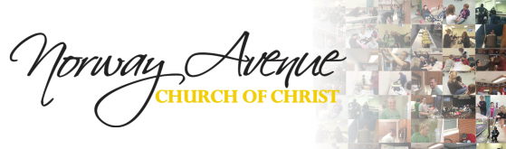
Diabetic Food Pantry Commitment
Food Pantry Ministry

I am committing to making disciples in our Jerusalem by providing a year of diabetic food boxes to the Norway Avenue Food Pantry Ministry. For the next 12 months, I commit to:
- Prepare one diabetic food box each month for the next 12 months, according to the specification below.
- Return my box each month by the 15th.
- Pray for this outreach, including all those involved and those being served here in our Jerusalem.
Items needed in your box each month:
- Canister of Oatmeal
- A loaf of whole grain bread
- Box of whole grain pasta
- Canned low sodium beans
- canned low sodium tuna
- 2 cans of low sodium vegetables
- 1 or 2 canned fruits in own juice
- I grocery bag for the food

My 12 month pledge of commitment:

______________________________
Name

______________________________
Date of Commitment

"For I was hungry and you gave me something to eat, I was thirsty and you gave me something to drink…." Matthew 25:35

Return to Jo Ann Marcum, Food Pantry Ministries
______________________________ __________________________
Name of Diabetic Box Pledger Date of Commitment

______________________________ __________________________
Best phone number Email address

